Preliminary-The MDS Simulation & Clinical Assessment Program - End of year feedback

Are you a student or a staff member?
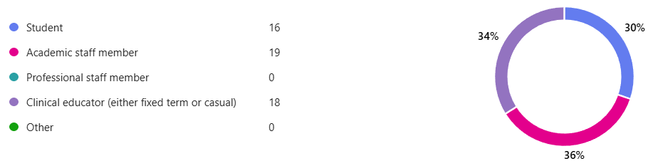

What year level were you in or did you teach into in 2025?
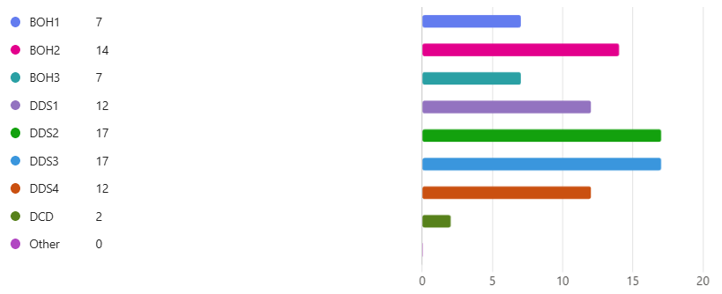

Where did you use the online assessment forms?
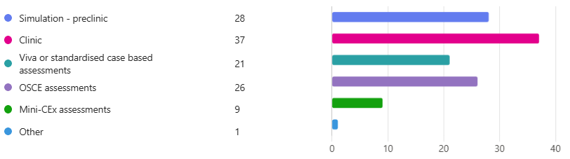

How would you rate your overall experience with the Qualtrics program as an assessment tool?
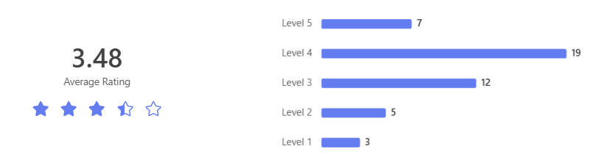

Do you have any comments on your experience specifically with Qualtrics?
Overall good, but too much to fill out
1- for the clinical setting, it is time consuming. 2- For the viva and OSCE, it is quick and helpful, appreciate it. I personally prefer to have more options than yes and no. The result should reflect the depth of knowledge of the student, and yes/no options are not enough in tertiary setting. There is no difference between the students who are going above and beyond in compare with the ones who just mentioned minimum.
It's a convenient way to record the progress of students. But the standardisation across all the clinical educators can be done a bit better. It could a Teach ME module on its own.

How would you rate your overall experience with the DASH program as an assessment tool?
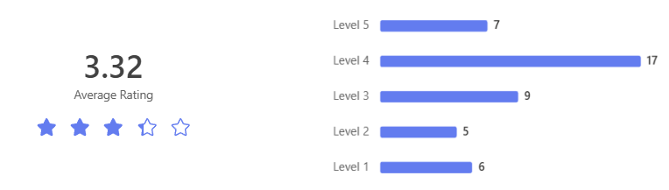

Do you have any comments on your experience specifically with DASH?
I thought the initial DASH form setup could be easier for example by selecting an option for a specific area for restoration which includes all the necessary sections, rather than having to separately select rubber dam isolation, preparation and restoration. I also thought if it would potentially help to include some prompt questions on the comment sections to help guide us on how we should be reflecting on our work.
Difficult for clinical staff who step in on the day (i.e. OHV dentist) to set up a usable account.
Hard to give useful feedback as spending all the time trying to fill in forms that don’t mean much to students bc most students are in the grey area between

Do you feel you received adequate training as a student, clinical educator or assessor for using the online assessment systems (Qualtrics or DASH)?

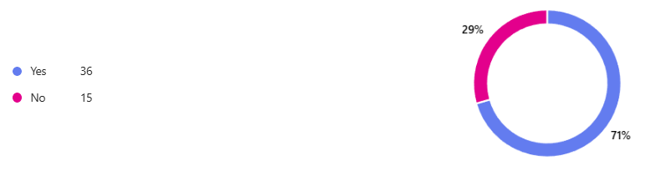

As a student how do you rate the regular feedback reports you received?
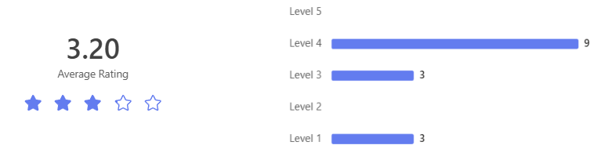

What improvements would you like to see in the student feedback reports?
I don’t think I read one of them. The feedback reports varied so wildly from what the demonstrators either told us in person or between demonstrators that it was entirely pointless
They were thorough and helpful
Good for tracking progress Feedback reports for exams would be appreciated or ability to see where you went wrong so you can learn from it.

As a staff member (typically component convener or subject coordinator) how do you rate the regular feedback reports you received?
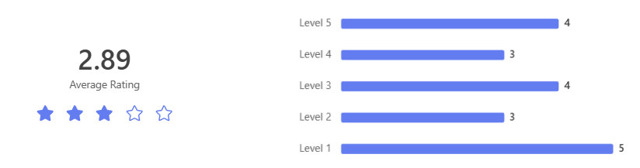

What improvements would you like to see in the staff feedback reports?
The reports were difficult to interpret and were not transparent to how students who were struggling were measured.
Regular reports without having to ask and chase data. Cleaned data. Making sure all notifications of critical incidents get sent and not just at the end of the semester, this is a big risk.
The feedback reports are great. The graphical representation of student progress over time just needs a red line for where the standard is set to show more clearly when students are below the line. More regular reports would be very helpful as well.

Clinical Educators - Reports weren't sent to clinical educators this year, but in 2026 we will finalise the dashboard that allows you to see the progress of the students you supervise. What would you like to see in these reports?
Actual evidence of competence; number of clinical sessions where there was a suitable patient, so actual progress can be determined.
Easy to follow graphs and tables that would be ease to discuss with students. Each student have a profile of key information. Item codes, clinical incidents, infection control issues. Need to be able to see how they are tracking and areas that need improvement
Previous comments made by myself and other supervisors so that I am aware of the individual student's strengths and weaknesses across all clinics. This would help guide my teaching to better support the student when they are under my care.

Subject Coordinators - Reports were sent in different ways across the programs to subject coordinators in 2025. What would you like to see incorporated into the dashboard in 2026?
Any enhancements that make the process of reading the reports easier/quicker. Although we have learned a lot, highlighting the essential student highs and lows enables coordinators to act quickly on any concerning data.
Analysis separated by clinic specialty but also combined Report provided as spreadsheet so we can sort by attendance rate, per clinic, for example. Currently very difficult to quickly flag the students who are falling behind. Tally of how many of each item number a student is recording so we can gauge what their clinical experience is. How many sessions they attended as operator/FTAs in total AND with a breakdown by specialty How many unique patients they are seeing Their grades/global rating per session, and progression over time. And all of the above compared with the cohort average/max/min Email notification of students of concern
graphs showing student progress over time clear presentation of data such as procedures completed highlight areas where a student will consistently perform poorly in certain line items automatic notifications for certain things contemporaneous results, ie results that are up to date especially when trying to have remediation meetings with students

What were some of the positive aspects of the online simulation and clinic assessment forms and reports?

Easy to access and look back on previous session to plan for future sessions
So many - efficient, can be accessed anytime by students to check, can be reviewed by educators at any time, great data collection, excellent reports, have been able to collect great evidence to show student performance.
They were quite straightforward and easy to use.

What where some of the challenges you experienced using the simulation or clinic assessment forms? Do you have suggestions for ways we can improve?
Binary checklists seem to cause reliability issues between assessors, so moving to a stepped sale will hopefully improve this. The forms were generally easy to use, but it would be helpful for subject coordinators to have oversight of all forms being submitted so all students and staff put them in.
Some supervisors from different cohorts not able to use dash, had to use other teachers’ names. be able to add temporary supervisors
Exceptionally long. Has a lot of issues and errors. Challenging to follow and justify to students. Excessive administrative load.

If you have ideas, requests or feedback that you feel hasn't been incorporated in the online simulation and clinic assessment forms, please record it here.
Need scaled responses for checklist fields, e.g. Incomplete, done (borderline), Done well, Exemplary Alerts for subject coordinators AND students when forms haven't been submitted Alerts when students are below a safety threshold Easier and quicker access to the data (with filters) to identify problems early and avoid wading through huge datasets
Questionnaire fatigue is real especially after busy clinic - curated list otherwise it becomes meaningless. Need to discuss the wording around the levels e.g. for readiness for practice. Define what it means for each cohort. Educator training. Feels very rushed for introduction in mid Jan.
The supervisor dashboard is messy; it used to separate completed forms but now incorporates them all in one list where you must switch between multiple pages to access the ones you are currently working on. Have sim seat numbers would help

Get in touch
 | www.unimelb.edu.au
 | info@unimelb.edu.au

